Dear colleagues

The TORCH Academy – Programme for Academic Women at Loughborough

In the context of our work on gender equity, I am delighted to announce a new programme to support the progression of academic women at Loughborough, and to attract new academic talent to the university. I believe that this programme could be ground-breaking, as it focuses not only on the individual, but as importantly, on the structures, systems, processes, and attitudes that might need to change to enable gender equity.

I am attaching some key information about the programme below, and if you are interested, I am inviting you to complete the short application form and submit to torch@lboro.ac.uk by June 04, 2021. My intent is to facilitate a brief launch event late June ahead of the programme starting in the autumn 2021. There will be two cohorts with 1215 participants in each cohort. We are looking for diverse cohorts of participants at Research, Lecturer, Senior Lecturer and Reader levels.

This programme will support your academic career progression and enable culture shift at Loughborough.

1. Why TORCH?
Instead of the usual acronym-based approach, we want our programme to be unique, career defining and differentiate from the already saturated market of ‘Women in Leadership’ programmes. We want to inspire Loughborough women academics to engage with the programme from the outset and share a common purpose of the clear and decisive steps needed to develop their leadership potential - and that the outcome is that the institution will be much stronger for it.

Based in part on the quote below by Audre Lorde - feminist, poet, and civil rights activist. ‘You need to reach down and touch the thing that’s boiling inside of you and make it somehow useful,’ Audre Lorde. When we are successful, we can pass the torch, reach down our hand and bring up the people that are still to go through it. The torch is our metaphor for bringing the passion and fire within oneself to develop, and when this is achieved, we are ready to pass the torch to our colleagues that are ready to rise up as we did.

Anticipated Programme Outcomes

- A clarity of ambition for the inclusion of women at Loughborough with defined ambitions and measurements.
- An engaged leadership team to help drive the delivery of this organisational priority.
- A series of defined recommendations which will provide the ingredients for a robust and Loughborough-specific action plan for women.
- A nuanced response to the progression of academic women at Loughborough that takes into account intersections, e.g., across race, disability, LGBT+, age, faith and social background.
- A step-change in attracting talented women to Loughborough.
- A link to our women’s network group, Maia, to ensure affinity with this programme of work and to encourage their mission and purpose.
- A cadre of visible and active role models and advocates for the inclusion of women. This would encompass the leadership team, managers, and a host of women at the University.

High-level Proposed Structure

- The programme has been designed and will be delivered by Fantail (see appendix one for biographies). o Work with 3 cohorts in total – 2 groups of 15 women, and 1 group of those who can influence their careers. o Delivery is via Zoom online sessions of 90 mins each.
- 2 facilitators – blend of full group input, then breakout into mini groups of 6 for discussions with a facilitator for each mini group.

  - Phase 1 – Insights and draft recommendations o 3 x input sessions per cohort (3 x 3 cohorts = 9 x 90-minute sessions in total).
  - Phase 2 – Recommendations finalised o 2 x recommendation refinement sessions with a subset of 2-3 people from each of the different cohorts. This will be supported by independent work and project management support from the People and Organisational Development team.
  - Phase 3 – Presentation, feedback, implementation, and impact. o Presentation to ALT – 2 women, 2 managers as spokespeople.
- Feedback to full programme group from ALT.

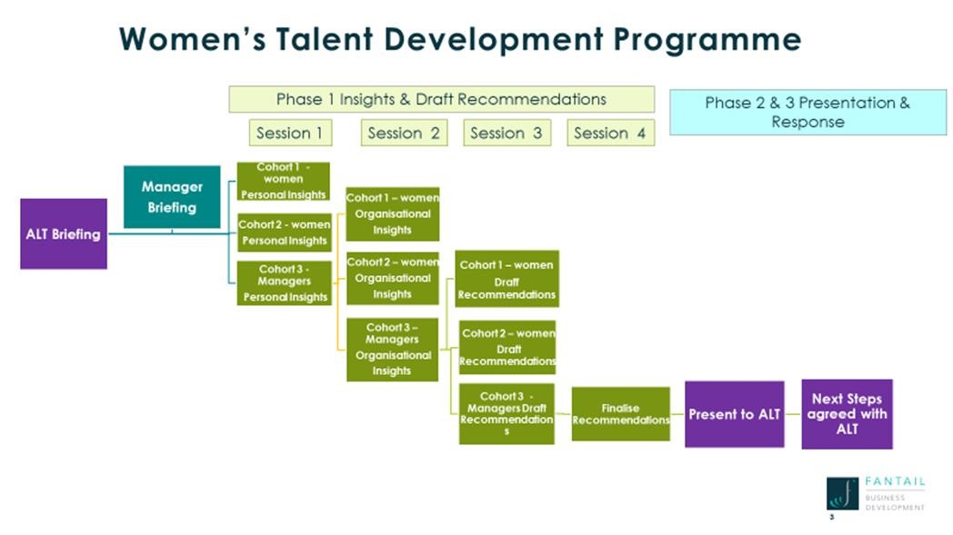

Application Process

Please complete the attached application (appendix 2) and return to torch@lboro.ac.uk by 04 June 2021. You will receive confirmation of participation in the programme by 10 June 2021.

The application timeline:

• | w/c 10 May | Information sent to potential participants and Deans.
• | w/c 17 May | Drop-in sessions for potential candidates to ask questions.
• | 04 June | Applications to be submitted to torch@lboro.ac.uk.
• | 10 June | Successful (and unsuccessful) participants will be notified.
Eligibility Criteria:

Baseline

- Candidates qualify through the grades chosen for the programme – R, L, SL, Reader.
- Candidates qualify as having met the standard for talent and potential to develop.

An appetite for the organisation, not just for self
- This is where candidates might have a more holistic view on the development of women at Loughborough where they can see the system and acknowledge the need to help change it to enable women to thrive.
- It is where they show a desire for something bigger than themselves, a sense of greater good for all women and for the University.
The Mix
- The candidate pool should reflect a wide diversity of candidates.
  - Demographic
  - Life experiences iii. Intersectionality Appendix One

The Fantail Team

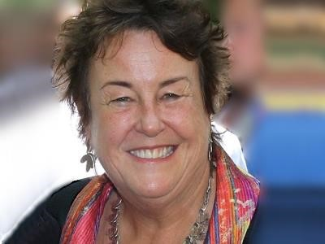

Liz Grant, OBE is a consultant who focuses on Inclusion in the workplace. She works across organisations and especially at senior leadership level, helping them to build inclusion into their culture and operations. Her experience as a leader in a corporate context provides valuable insights to the day-to-day challenges of managing complex, matrix-managed organisations. This informs the work Liz does with clients throughout their businesses.

Her clients include a wide range of financial services, insurance, technology and media companies as well as academia and not-for-profit organisations. Liz has worked as an advisor to many workplace diversity groups and has
judged a number of awards including the Apollo Project Awards, Insurance Insider Honours, British LGBT Awards, TTG Travel awards programmes – all for their Diversity & Inclusion categories.

She is a trustee for Open for Business.

Over a period of 10 years Liz was a trustee and Vice Chair of the Board of Stonewall, where she had Board leadership for their workplace programmes. She stood down from Stonewall in 2012. She was recognised in the 2013 New Year’s Honours when she was made Officer of the Order of the British Empire (OBE) for services to Lesbian, Gay, Bisexual and Transgender equality in the workplace.

Jo Bostock, MBE specialises in working with clients to develop high-performing, inclusive cultures that make the most of their diverse talent. She primarily works with senior leaders on what leadership means to them and how they can exercise their influence as powerful role models.

Jo’s work encompasses executive coaching, group facilitation, public speaking, research and writing. She has supported leaders across a wide range of businesses including Microsoft, Accenture, the University of Cambridge, AIG, Dentsu Aegis, the RIBA, Lloyd’s of London, Tate, EY, BNP Paribas, the BBC and UNICEF.

She has also written three publications that explore the value and impact of diverse role models – “Role Models: Sexual Orientation and the Workplace”, “The Meaning of Success – Women at Cambridge” and the RIBA Role Model Project.

Jo blends her consultancy work with her role as co-founder of the Women’s Sport Trust – a leading charity dedicated to using the power of sport to accelerate gender inclusion. She was recently voted one of the top 20 most influential women in British sport.

Jo is a regular spokesperson on gender, inclusion and sport for media including the BBC, Sky, the Guardian, the Times and the Independent.

In 2019 New Years’ Honours Jo was made a Member of the Order of the British Empire (MBE) for services to gender equality in sport.

Appendix Two

Name
Grade
School
Protected Characteristics (Optional)
In no more than 300 words, please describe how this programme might help you in fulfilling your career aspirations.

In no more than 300 words, please describe your role in ensuring that Loughborough is an environment in which all colleagues can thrive and perform at their best.

In no more than 300 words, please describe how you would like to contribute to enabling organisational change within the gender equity space.

